Jimi Porter

CIS 310-01

Due Date 09/15/2019

Chapter 4 Homework

21.

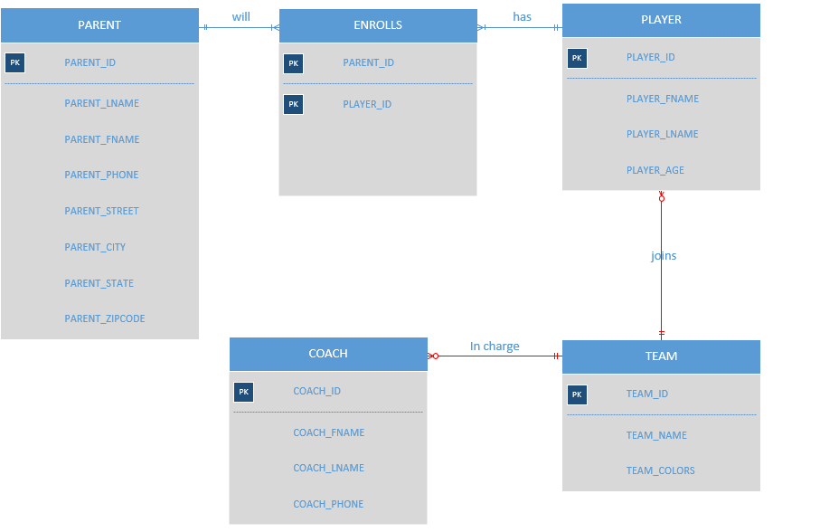

**\*\* Weak entity relationship is shown through red line in the diagram for problem 21.\*\***

1. 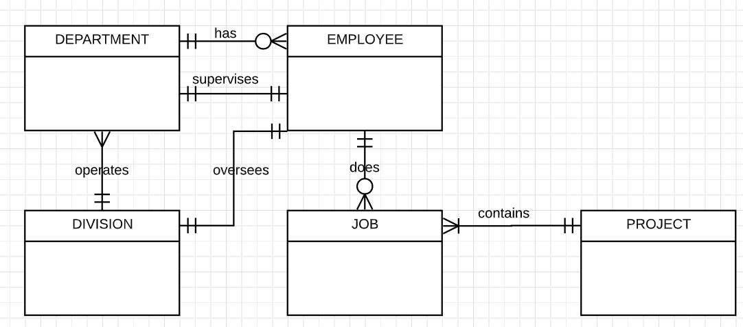

**\*\*All the connections are weak relationships.\*\***